**ER Diagram**

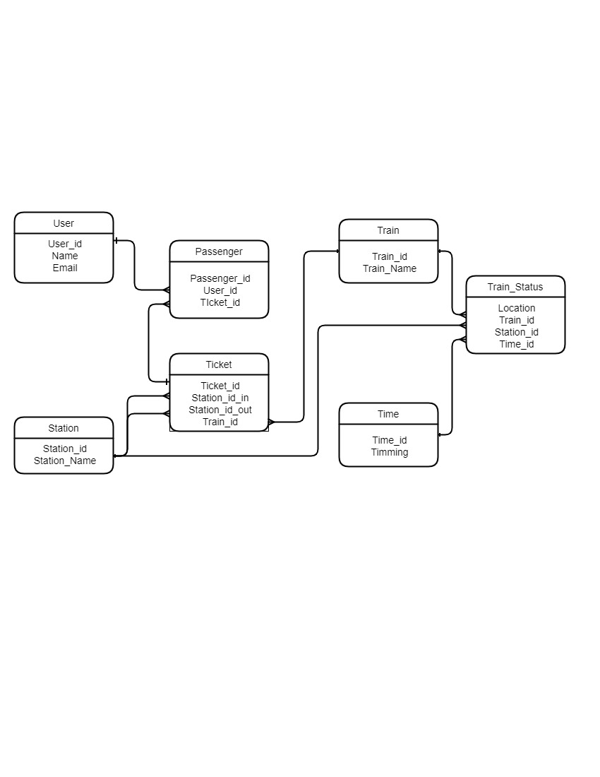

**Structure of Tables**

**User :**

create table user (user_id int primary key(11), name varchar(20), email varchar(50));

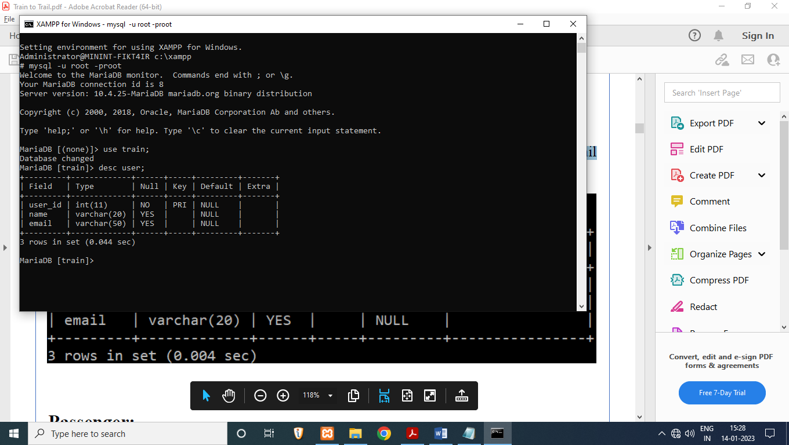

**Passenger :**

create table passenger (passenger_id int(11) primary key, user_id int(11), ticket_id int(11));

alter table passenger add constraint fk_userid foreign key (user_id) references user(user_id);

alter table passenger add constraint fk_ticketid foreign key (ticket_id) references ticket(ticket_id);

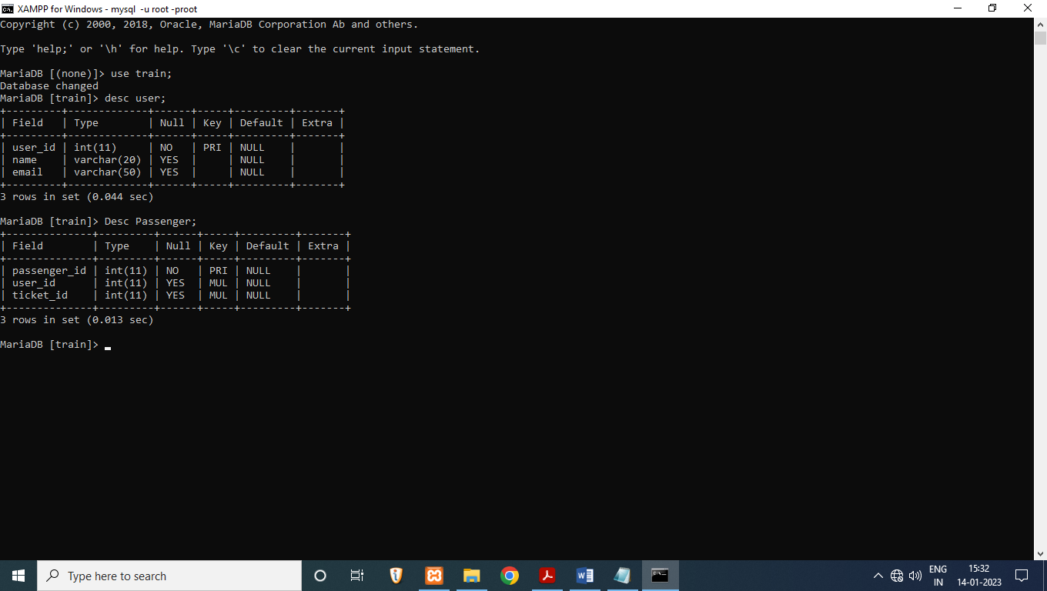

**Station :**

create table station (station_id int(11) primary key, station_name varchar(20));

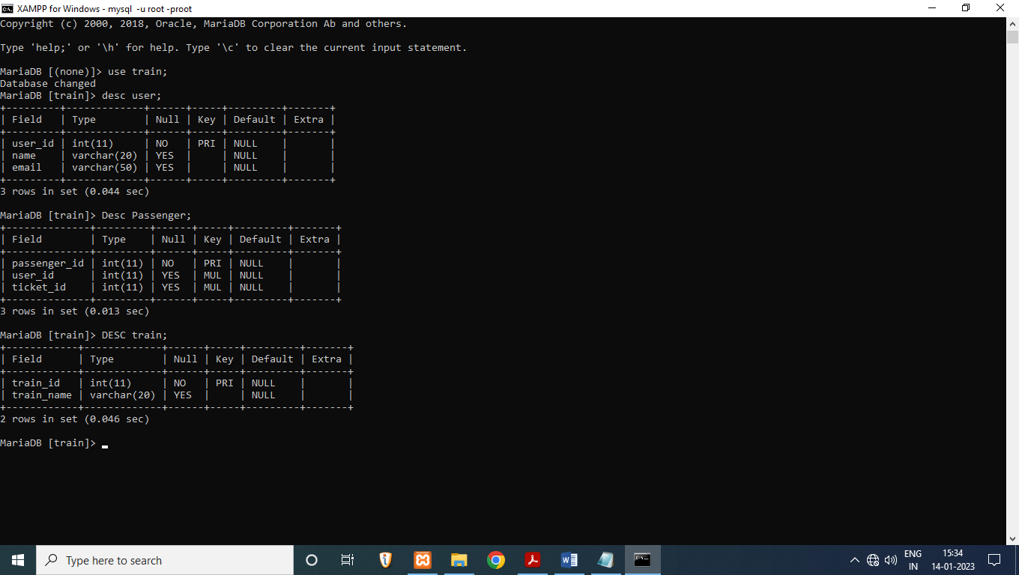

**Train:**

create table train (train_id int(11) primary key, train_name varchar(20));



**Ticket:**

create table ticket (ticket_id int(11) primary key, station_id_in int(11), station_id_out int(11), train_id int(11));

alter table ticket add constraint fk_stationid foreign key (station_id_in) references station(station_id);

alter table ticket add constraint fk_stationid2 foreign key (station_id_out) references station(station_id);

alter table ticket add constraint fk_trainid foreign key (train_id) references train(train_id);

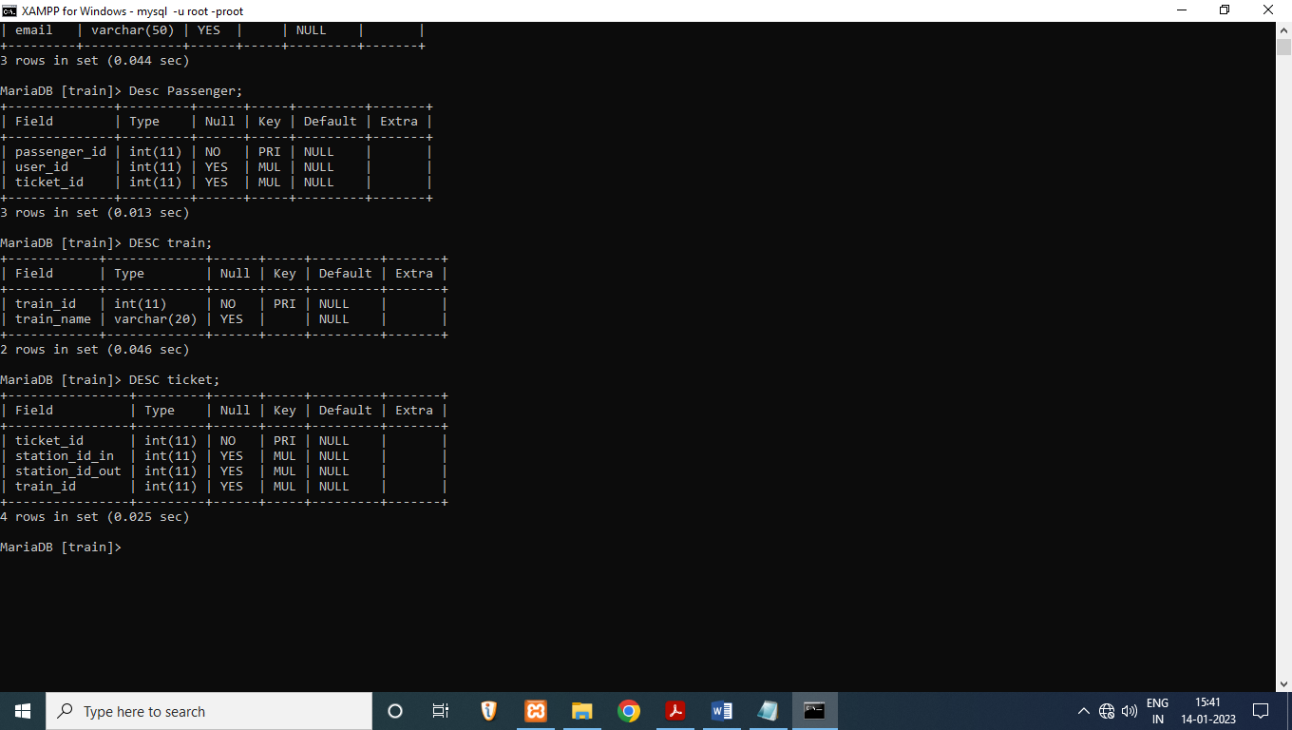

**Time:**

create table time (time_id int(11) primary key, timming time);

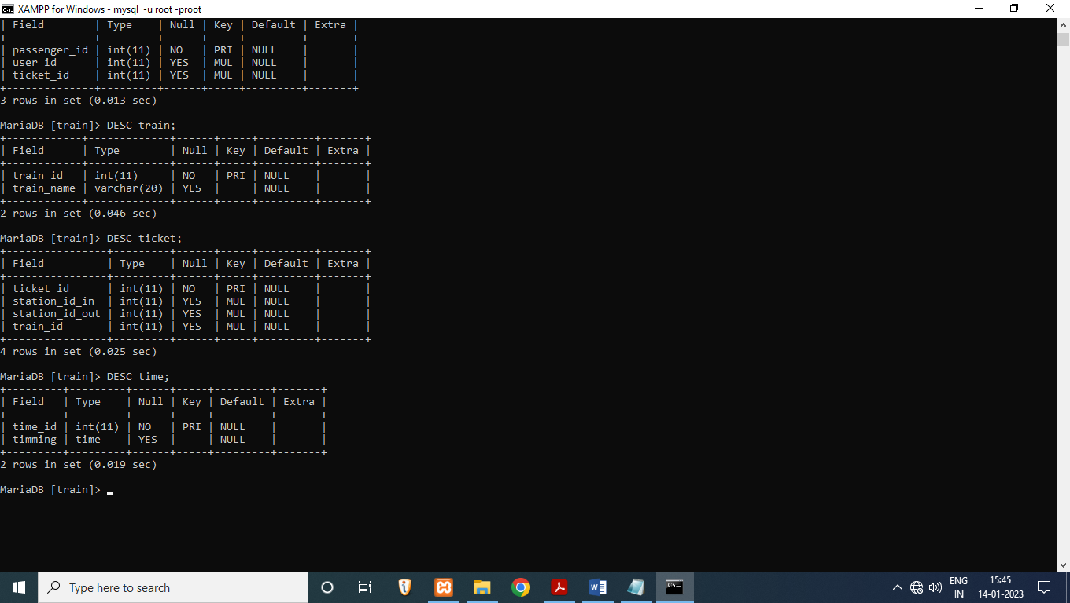

**Train_status:**

create table train_status (location int(11) primary key, train_id int(11), station_id int(11), time_id int(11));

alter table train_status add constraint fk_trainid foreign key (train_id) references train(train_id);

alter table train_status add constraint fk_stationid1 foreign key (station_id) references station(station_id);

alter table train_status add constraint fk_timeid foreign key (time_id) references time(time_id);

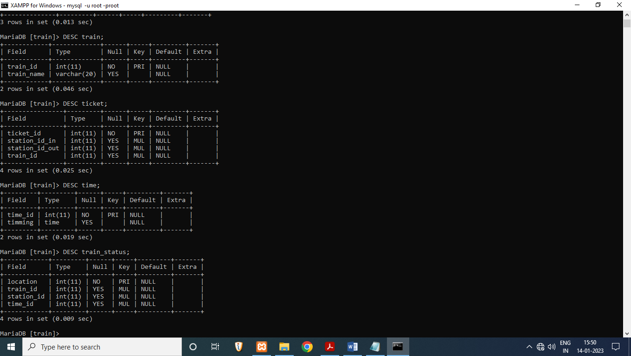

**Content of Tables**

**User :**

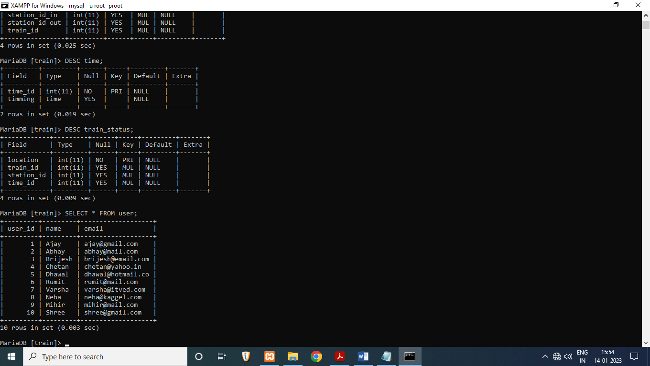

**Passenger :**

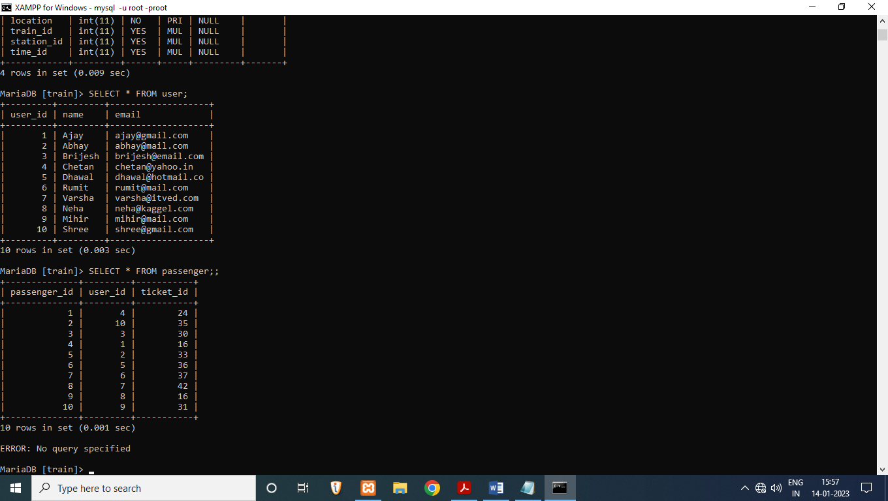

**Station :**

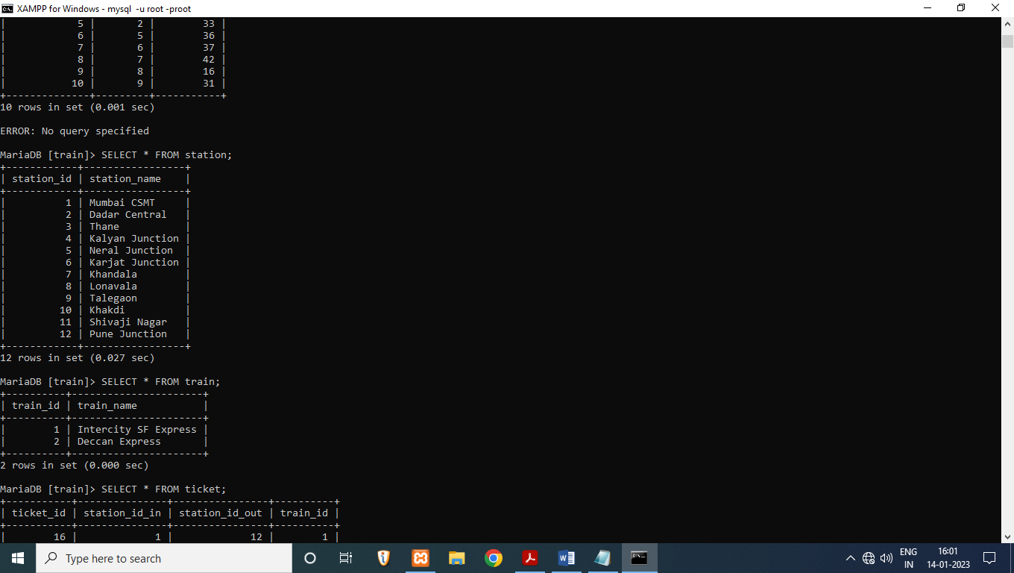

**Train :**

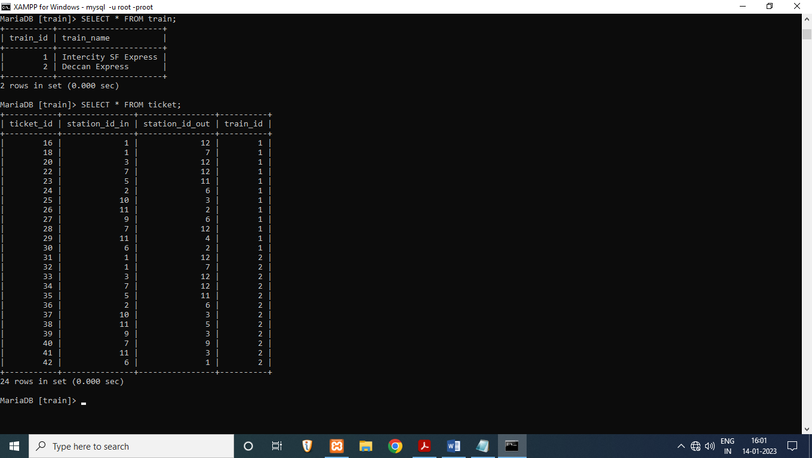

**Ticket :**



**Time :**

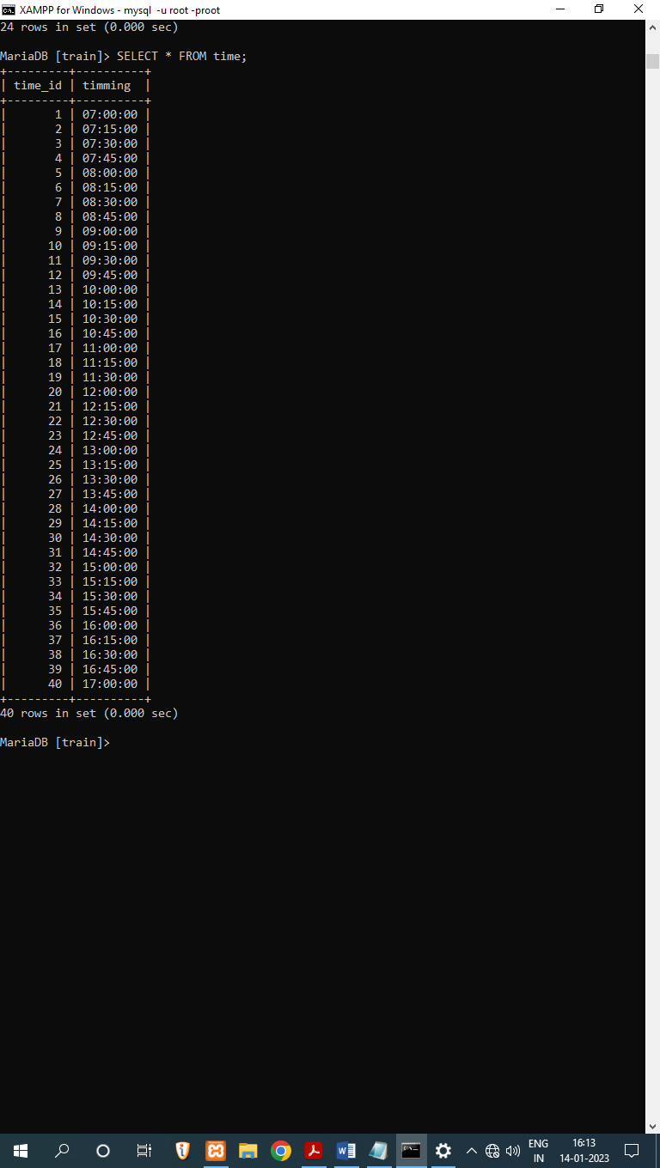

**Train_Status :**

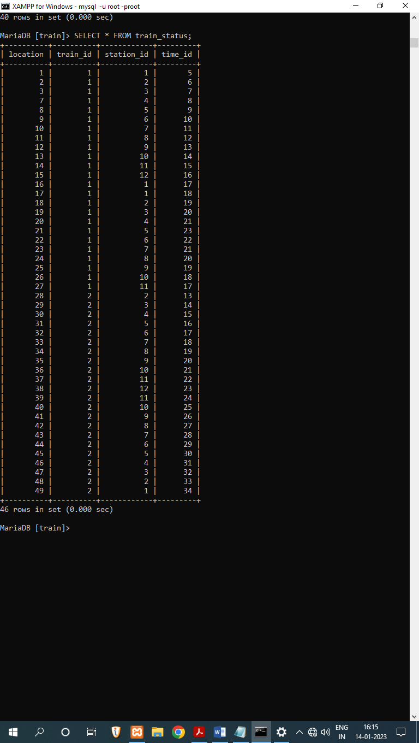

**Subqueries**

**Locate the train at a particular time:**

select station_name from station where station_id in (select station_id from train_status where time_id = (select time_id from time where timimg='09:30:00') and train_id = (select train_id from train where train_name="Intercity SF Express" ) );

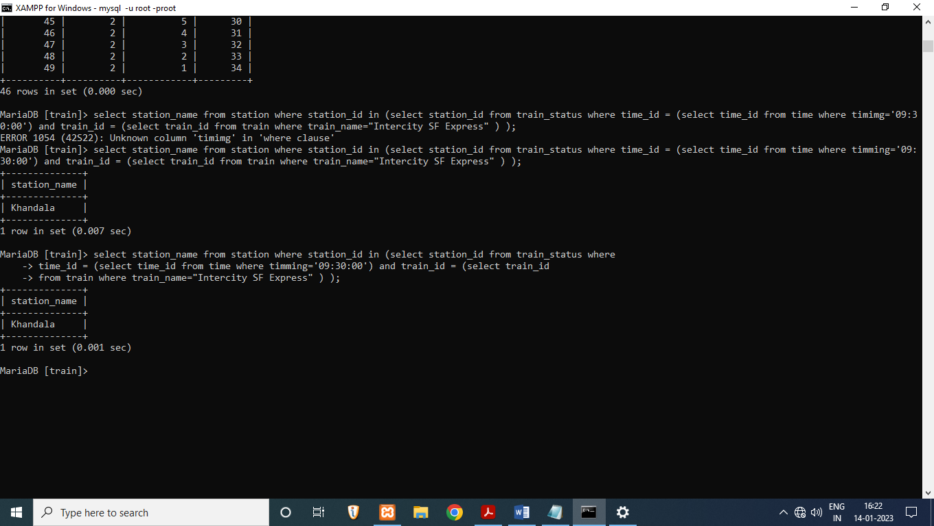

**Location from where the individual is travelling:**

select station_name from station where station_id in (select station_id_in from ticket where ticket_id = (select ticket_id from passenger where user_id = (select user_id from user where name = 'abhay' ))) union select station_name from station where station_id in (select station_id_out from ticket where ticket_id = (select ticket_id from passenger where user_id = (select user_id from user where name = 'abhay' )));

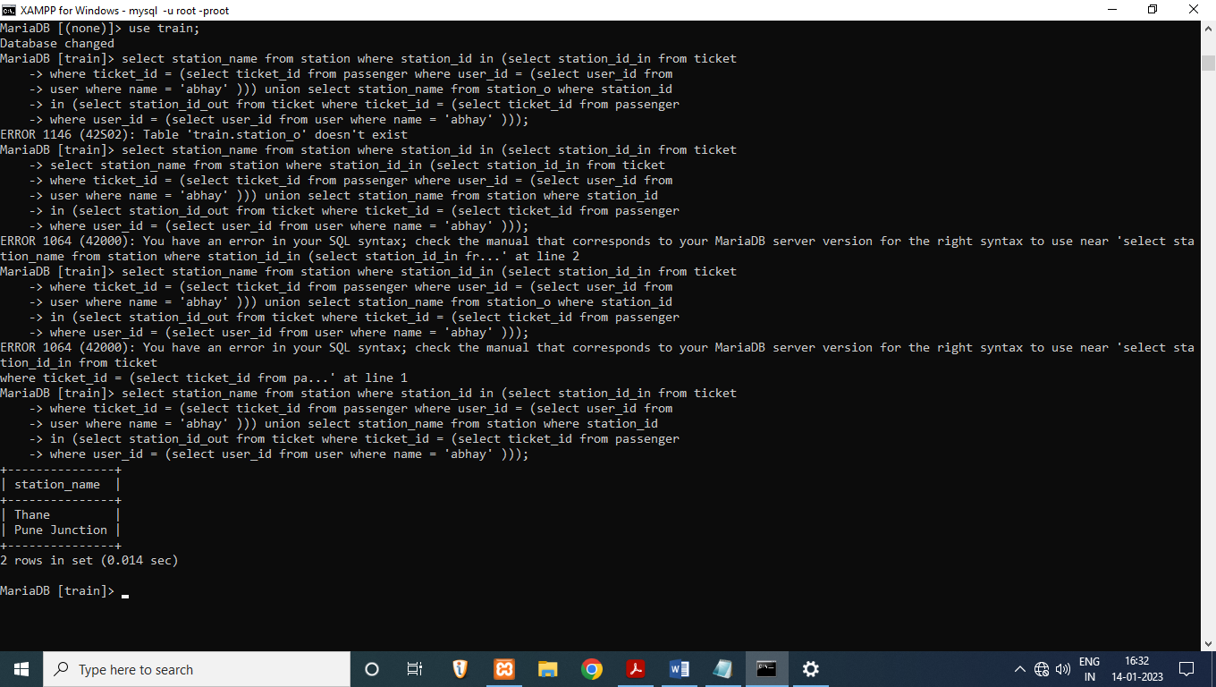

**Name of the train from which user is travelling:**

select user.name , train.train_name from user ,train where user_id=(select user_id from user where name = 'dhawal') and train_id = (select train_id from ticket where ticket_id = (select ticket_id from passenger where user_id = (select user_id from user where name = 'dhawal') ));

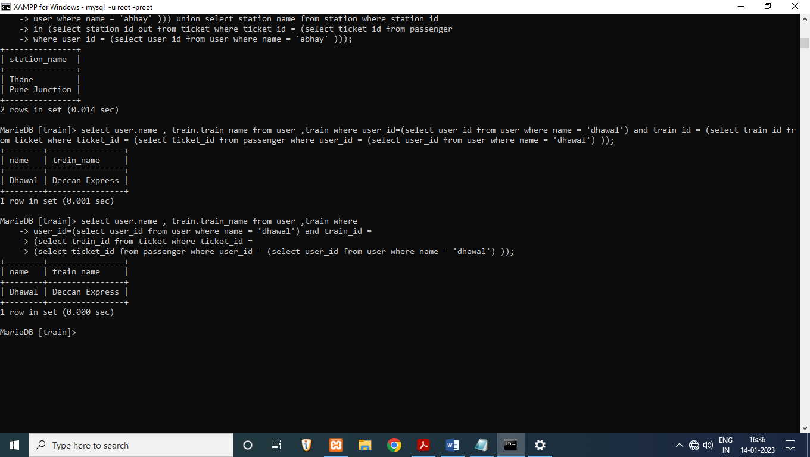

**Joins**

**Joining ticket with train and station name to understand where passengers are travelling and by which train:**

SELECT ticket.ticket_id, station.station_name, train.train_name FROM ticket join station ON ticket.station_id_in = station.station_id or ticket.station_id_out = station.station_id join train ON train.train_id = ticket.train_id order by ticket.ticket_id;

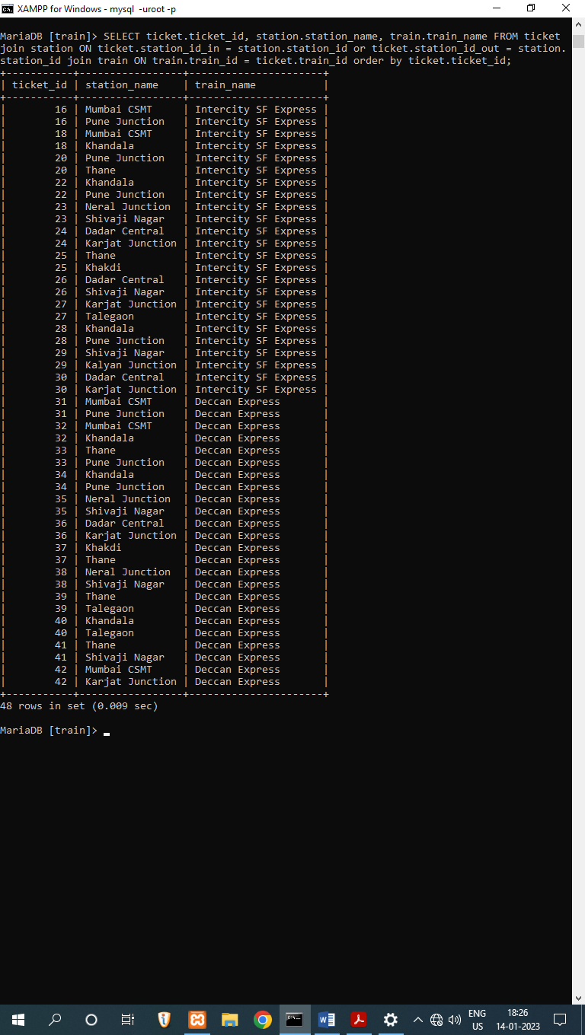

**Joining train_status to train location, train, and it’s time to understand train schedule according to train location and train name:**

select train_status.location, train.train_name, station.station_name, time.timimg from train_status join train on train_status.train_id = train.train_id join station on train_status.station_id = station.station_id join time on train_status.time_id = time.time_id order by time.timming;

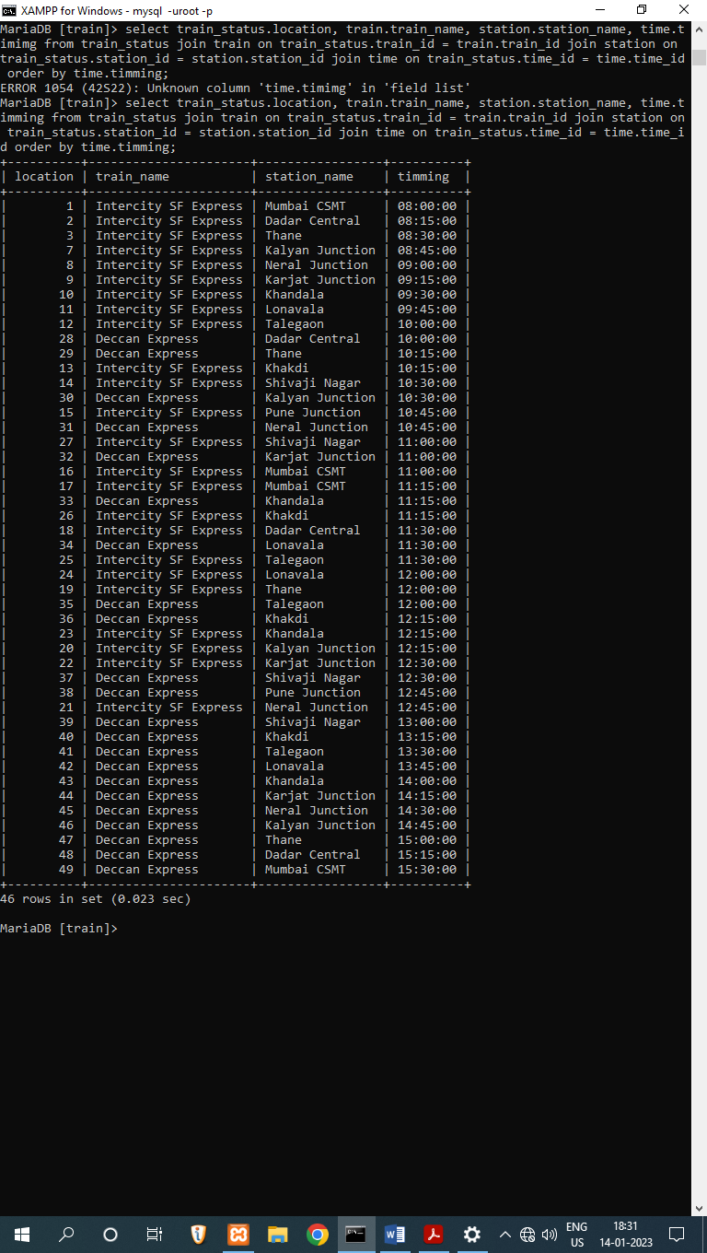

**Views**

**Using views to store above joined tables for future references:**

create view ticket_info as SELECT ticket.ticket_id, station.station_name as boarding, station.station_name as deboarding, train.train_name FROM ticket join station ON ticket.station_id_in = station.station_id or ticket.station_id_out = station_o.station_id join train ON train.train_id = ticket.train_id order by ticket.ticket_id;

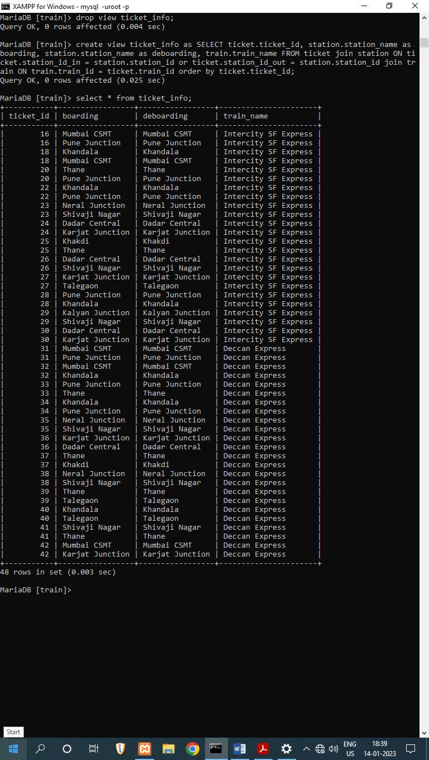

create view schedule as select train_status.location, train.train_name, station.station_name, time.timming from train_status join train on train_status.train_id = train.train_id join station on train_status.station_id = station.station_id join time on train_status.time_id = time.time_id order by time.timming;

